1. Simple console app Hello world. I can change output text

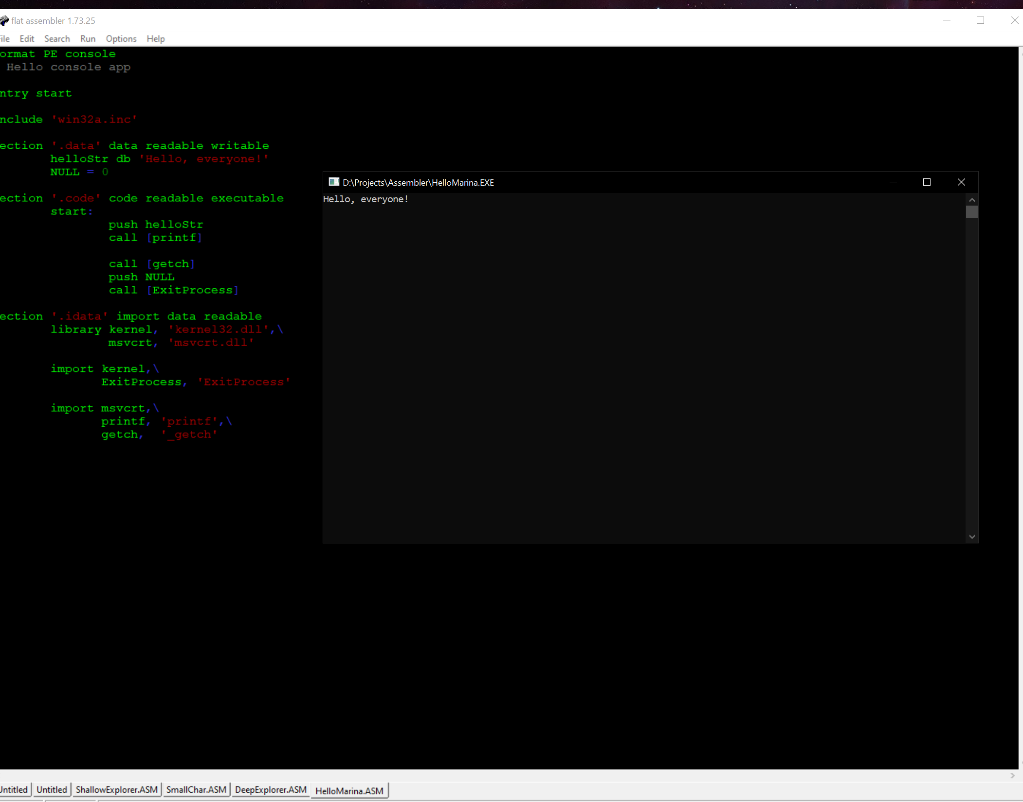

1. Custom console app, we can change it’s size and set time before destruction

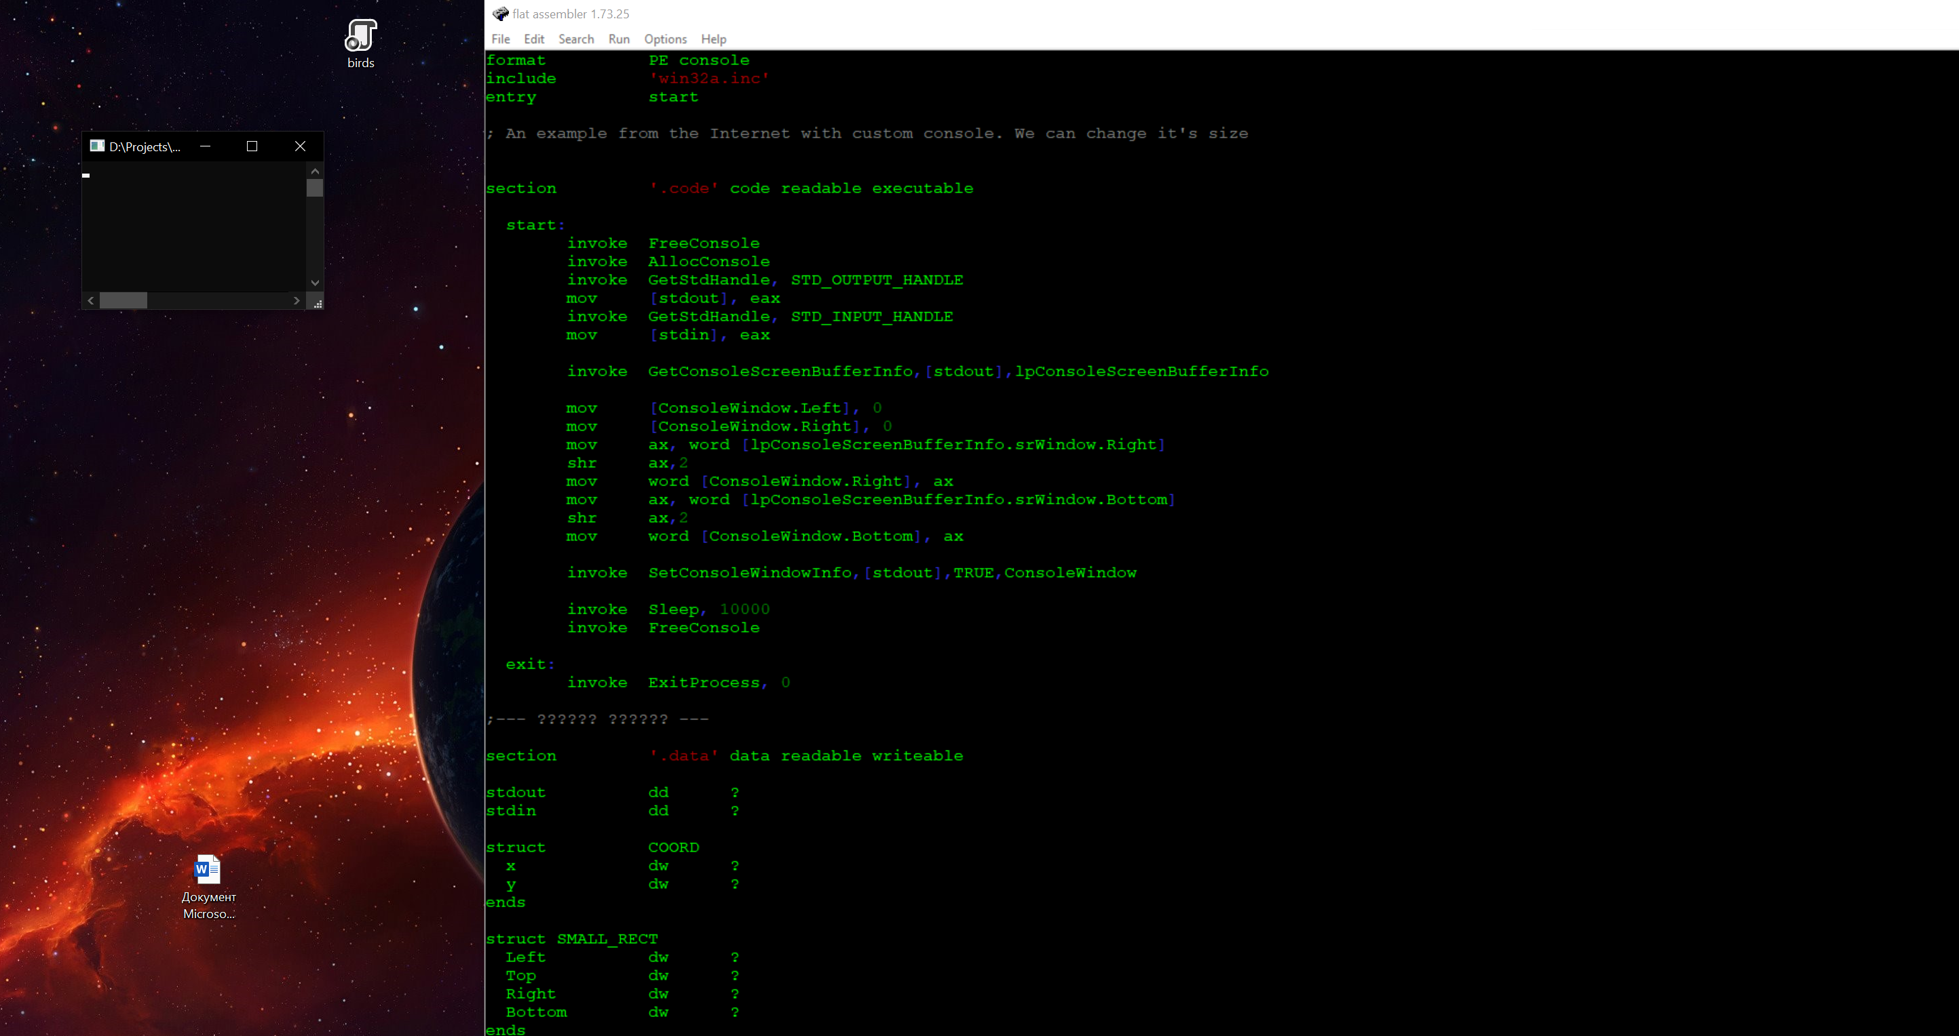

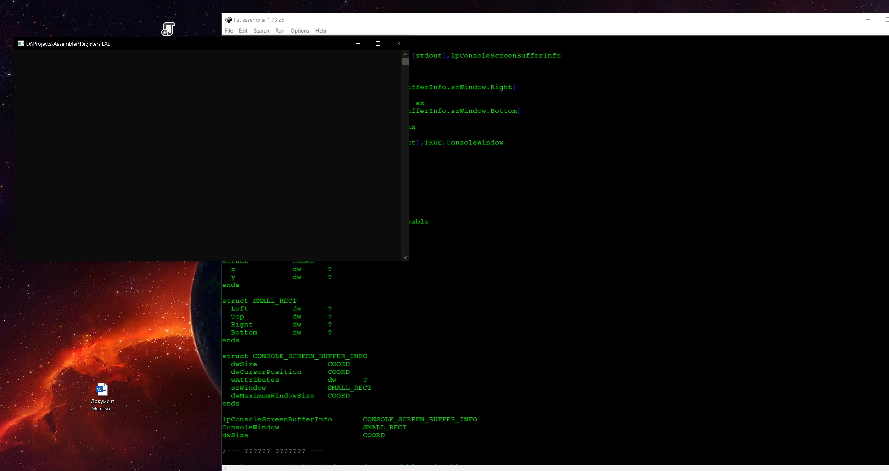

1. Here I changed color and shape of the figure

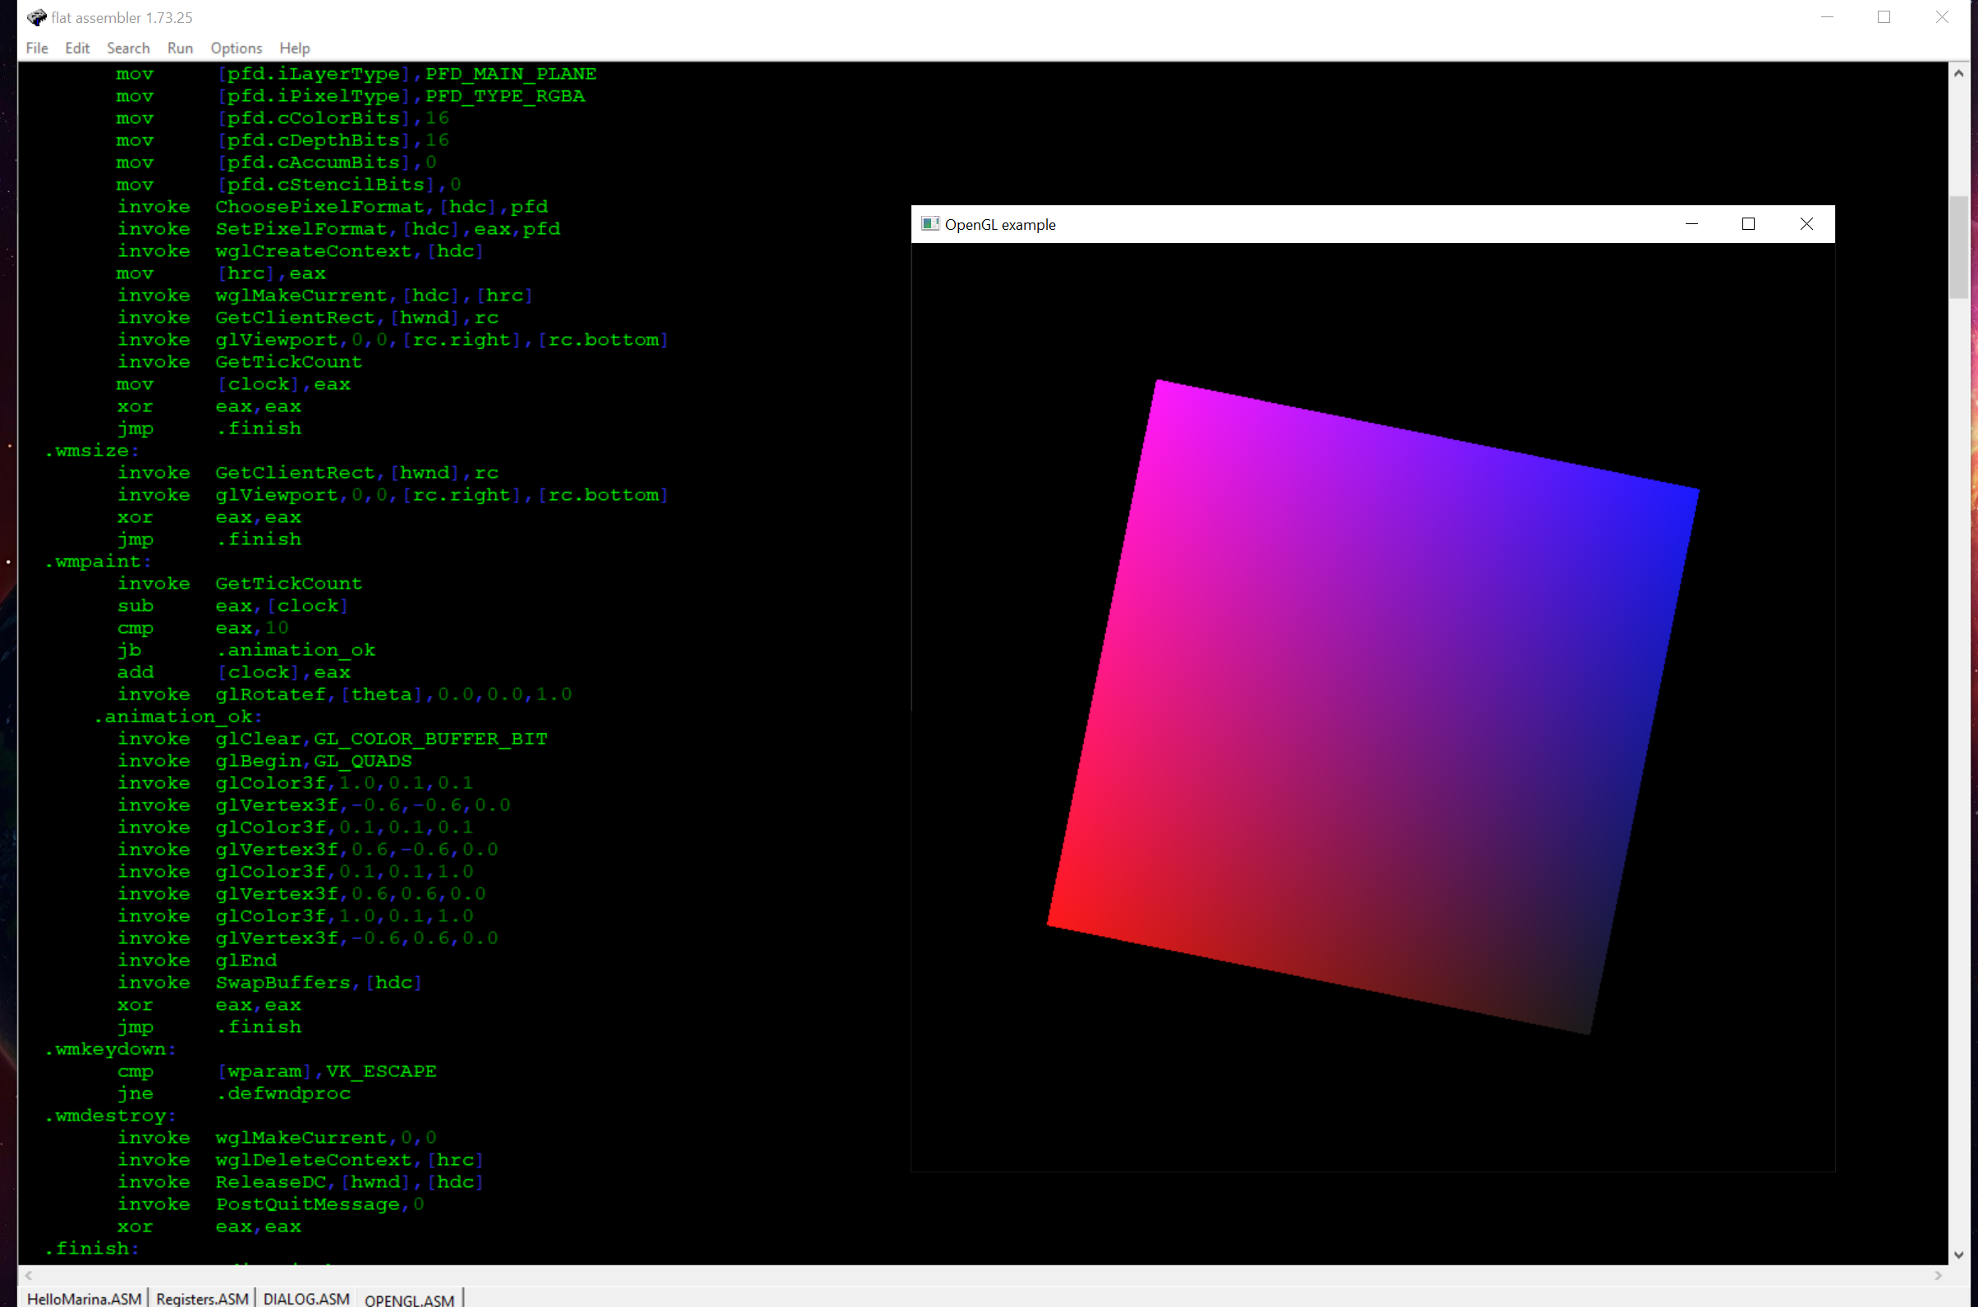

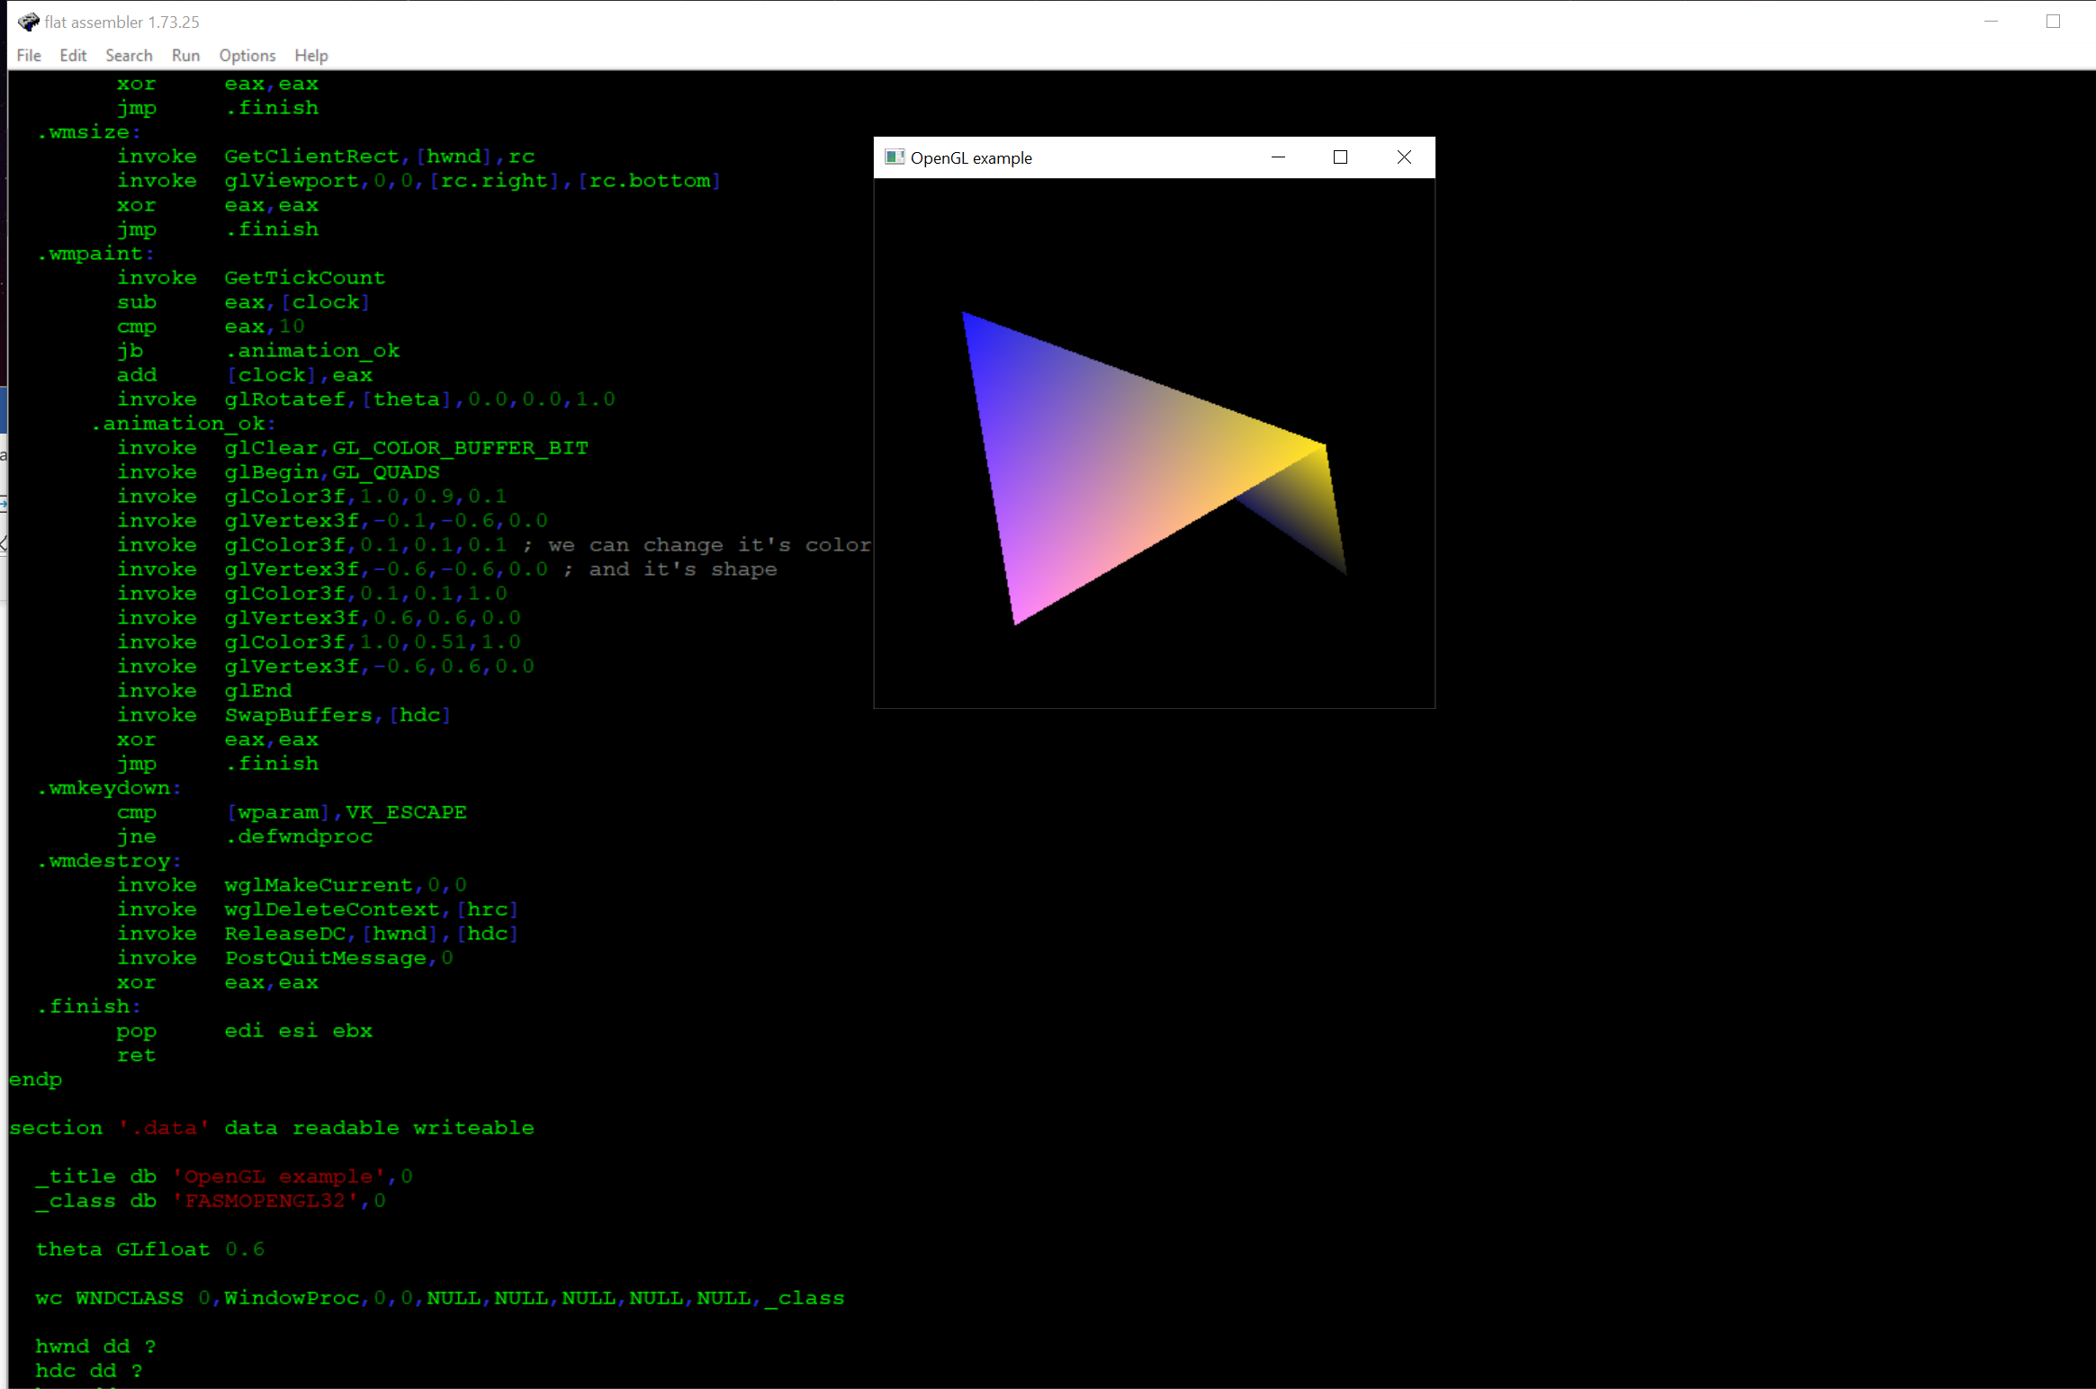

1. We can change text value of the toolbar items

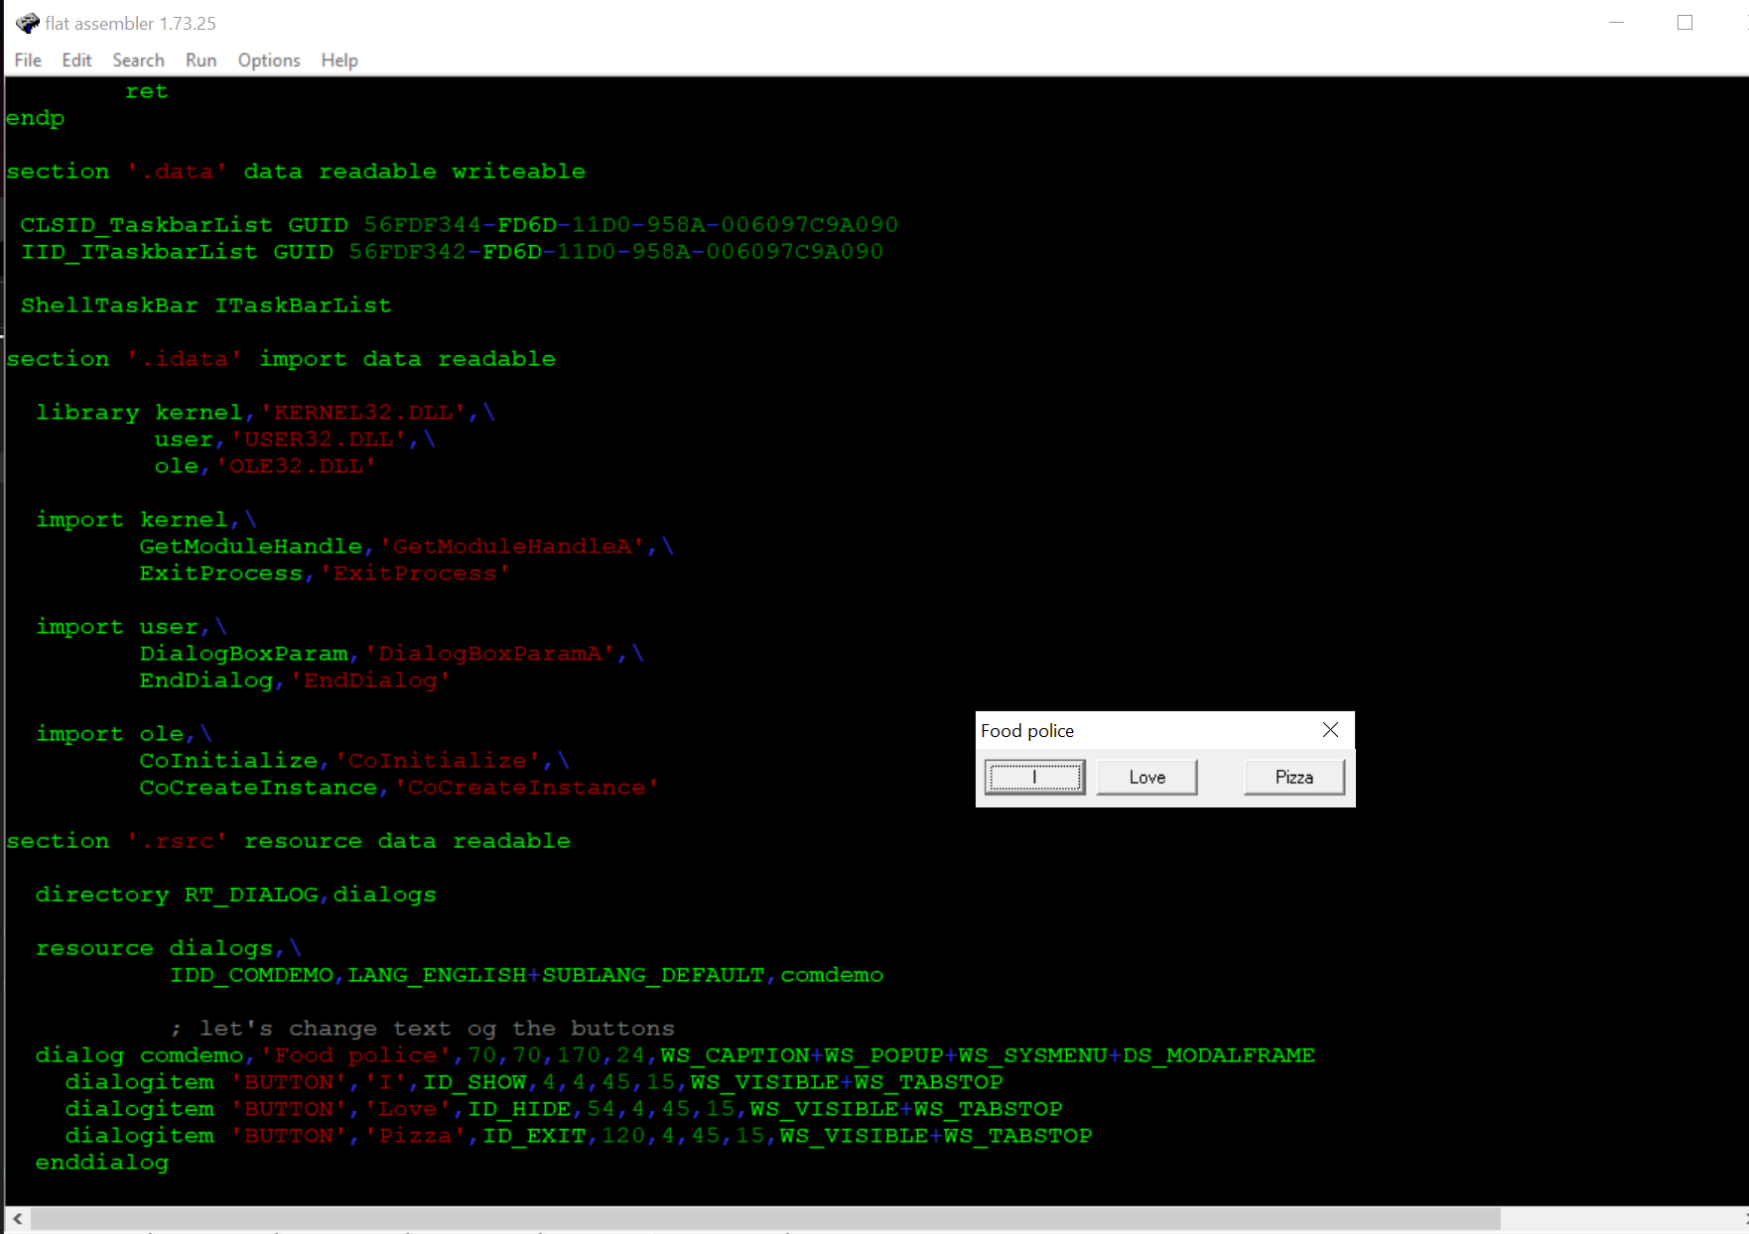

1. I’ve found a very beautiful visualization of the Maldenbrot fractal and changed it’s color

